A progress report

On

IoT Based Multi-Purpose Unmanned Surface Vehicles for Surveillance and Rescue Operations

In partial fulfilment of the requirements for the award of the Degree of

Bachelor of Technology in Electronics and Communication Engineering

From

MAULANA ABUL KALAM AZAD UNIVERSITY OF TECHNOLOGY, WEST BENGAL



Submitted by

* Brishti Sarkar
* Shreya Banik
* Somdatta Das

Under the supervision of

Subhajit Roy, Assistant Professor ECE department



HOOGHLY ENGINEERING & TECHNOLOGY COLLEGE

Vivekananda Road, Pipulpati, Hooghly

West Bengal 712103

Session: 2020-2021

**Acknowledgement**

We have immense pleasure in successful completion of this work titled: IoT Based Multi-Purpose Unmanned Surface Vehicles for Surveillance and Rescue Operations .

The special environment at **HETC**, Hooghly that always supports educational activities, facilitated our work on this project.

We acknowledge the support, the encouragement, extended for this study by our **Supervisor Prof. Subhajit Roy** and **Co-Ordinator Prof. Jagadish Bhattacharya**.

We greatly appreciate and understanding extended for the project work, **Prof. Subhajit Roy**, who responded promptly and enthusiastically to our requests for frank comments, despite their congested schedules. We are indebted to all of them, who did their best to bring improvements through their suggestions.

We are also thankful to our college’ **Library Staff & Administrative Staff HETC** college, who directly or indirectly have been helpful in some or the other way.

We thank our Dearest parents, who encourage us to extend our reach. With their help and support, we have been able to complete this work.

**Abstract**

Disaster robotics has become a research area in its own right, with several reported cases of successful robot deployment in actual disaster scenarios. Most of these disaster deployments use aerial, ground, or underwater robotic platforms. However, the research involving autonomous boats or Unmanned Surface Vehicles (USVs) for Disaster Management (DM) is currently spread across several publications, with varying degrees of depth, and focusing on more than one unmanned vehicle—usually under the umbrella of Unmanned Marine Vessels (UMV).Our project attempts to explore the possibility of designing and implementing an Unmanned Surface Vehicle (USV) in form of a Boat with a Surveillance Camera installed for search and rescue operations at Water bodies. This USV can be controlled over the internet using concepts of Internet of Things. The main Microcontroller will be NodeMCU for handling all the control features and sensor implementations. NodeMCU has an inbuilt microcontroller along with a Wi-Fi module ESP8266 12E. The boat will use DC motor and propeller for actuation and servo for Radar control. It has an onboard GPS for Location tracking and in case of any anomaly Quick response team can be sent at that location. The Power supply for the boat is divided into two parts-Li-ion 18650 batteries for delivering power at night and Solar Panels for charging those batteries whenever possible. This architecture for power delivery will ensure long mission times (months) without coming back to base station for recharging. An action camera with pan and tilt features will send live video feed over the internet to the base station. The boat can be controlled using an app or a webpage. It is expected to be manufactured at a low cost and multiple such USV can work in Collaboration to handle Disasters at waterbodies.

**KEYWORDS –Unmanned Surface Vehicle (USV), Disaster Management (DM), NodeMCU, Internet of Things, Solar Power. GPS Tracking, 18650 Li-Ion, Surveillance Camera.**

**Contents**

**Chapters Pg. No.**

1. Introduction 1
   1. Purpose of this Project 2
2. Literature Survey and Related Works 2
3. Proposed System 2-3
4. Block Diagram 3
5. Flow Chart 4
6. Hardware Description 5-8
   1. Arduino Board 5
   2. NodeMCU ESP8266 12E 5
   3. Passive Infrared Sensor PIR 5-6
   4. Li-ion 18650 Cell 6
   5. Battery Management Circuit 6
   6. MOSFET 7-8
   7. DC Motor 8
7. Servo Motor in Depth 8-9
   1. How SErvo Motors work 8-9
   2. Servo Motor Pinout 9
   3. Wiring Servo Motor to Arduino UNO 9
   4. Arduino Code - Sweep 10
   5. Explanation 10
8. Power Supply 11
   1. Working Principle 11
9. Software Requirement 11-12

9.1 Blynk Requirements 12

1. Internet of Things (IoT) 12
   1. Introduction to IoT 12-13
   2. Enabling Technologies for IoT 13
   3. Characteristics 13-14
   4. Advantages of Internet of Things 14
   5. Disadvantages of Internet of Things 14-15
2. Circuit and Simulation 15
   1. Interfacing DC Motor 15
   2. Interfacing Servo Motor 16-17
   3. Combining DC motor and Servo Interface Circuits 18
3. List of Materials 19
4. Advantages 20
5. Application 20
6. Conclusion 20
7. Future Scope 21
8. References 21
9. **Introduction**

The main purpose behind this project is developing an Unmanned Surface Vehicle (USV) platform that can be used for multiple purpose like – defense or surveillance and rescue etc.

India’s long coastline presents a variety of security challenges including illegal landing of arms and explosives at isolated spots on the coast, infiltration/ex-filtration of anti-national elements, use of the sea and off shore islands for criminal activities, and smuggling of consumer and intermediate goods through sea routes. Absence of physical barriers on the coast and presence of vital industrial and defense installations near the coast also enhance the vulnerability of the coasts to illegal cross-border activities. In addition, the Indian Ocean Region is of strategic importance to India’s security. A substantial part of India’s external trade and energy supplies pass through this region. The security of India’s island territories, in particular, the Andaman and Nicobar Islands, remains an important priority. Drug trafficking, sea-piracy and other clandestine activities such as gun running are emerging as new challenges to security management in the Indian Ocean region. FICCI believes that industry has the technological capability to implement border management solutions. The government could consider exploring integrated solutions provided by industry for strengthening coastal security of the country. The FICCI-PwC report on ‘Smart border management: Indian coastal and maritime security’ highlights the initiatives being taken by the Central and state governments to strengthen coastal security measures in the country. The report also explores key challenges to coastal security and considers some of the international examples from countries like France, Japan, Russia, the UK and US, which could be relevant to designing coastal security strategies in India. I sincerely hope that this report will offer important and useful insights to the government, enforcement agencies and all other stakeholders.

Apart from maritime accidents, the development of criminal activities has been taking place, such as smuggling, transfer of criminals and terrorists and even slavery. The world community, led by the European Union (EU) Member States and Turkey, as the major refugee shelter countries, have provided a series of measures to suppress the negative consequences of the migrations and increase the efficiency of life saving during the process. These measures include all the ships navigating in the Mediterranean Sea. While the Navy, Coastguard and Search and Rescue (SAR) specialized vessels are constantly present on the most frequent migration routes, often leading the SAR operations, merchant ships have a very important role as well. In cases where merchant ships are engaged in such rescue operations, the masters and crew members are exposed to a number of safety, health and security related specific threats, often with very limited experience, knowledge and resources for these situations.

It is thus, very critical to perform search and rescue operations on sea and large water bodies. It requires extensive number of resources and time to locate humans in need of saving. In such cases such Unmanned Robots can help speed-up the Search and rescue process and also reduce the resource expenditure. This paper deals with the technical background details required for this project.

* 1. **Purpose of this project:**

This project “Multi-Purpose Unmanned Surface Vehicles for Surveillance and Rescue Operations” using domain of Internet of Things (IoT) is used mainly in Defense and Rescue purpose. This will help provide better security and surveillance capabilities to our Sea borders and restrict unauthorized infiltration attempts. It may also be used to save lives in case of a natural disaster.

1. **Literature Survey and Related Works**

In the literature survey conducted, there are different approaches developed for Unmanned Surface Vehicle. For instance, in paper **Unmanned Maritime Systems for Search and Rescue** deals with the development of maritime unmanned tools for search and rescue operations is not a trivial task. A great part of maritime unmanned systems developed did not target such application, being more focused on environmental monitoring, surveillance or defense. In opposition to these applications, search and rescue operations need to take into account relevant issues such as the presence of people or other vessels on the water. Building upon user requirements and overall integrated components for assisted rescue and unmanned search operations (ICARUS) system architecture, this chapter addresses the development of unmanned maritime systems. It starts with an overview of the approach where a two‐tier solution was adopted to address safety issues and then proceeds to detail each of the developed technologies.

Another such project - Remote Control Rescue Robotic Boat for Search Operation. The aim of this project was to design such a robotic boat which will help us to find those cars plans and other metal things which drowned in the river or in the sea or in the pound. We can control the robotic boat while sitting outside the sea or river. We can make it to move right, left, forward by controlling it through remote using visual basic the signal will be sent through transmitter and received by receiver. The direction of the boat will be changed through propellers with which motors are connected. In this boat we will install under water wireless camera, which will indicate us about the thing which are drowned under the water and it will tell us by switching on and off the desired light which will be used as an alarm, that where are our drowned things under the water. It will also help us in rescue work.

1. **Proposed System**

The design of this Unmanned Surface Vehicle resembles that of a Speed Boat. This design provides stability and speed at the same time. The boat has a high-power DC motor coupled with a propeller to provide thrust. The direction of this thrust vector is controlled by a rudder assembly developed with aluminum profile and 3D-Printed hinges. The rudder is rotated at a specific angle based on the signals provided by the main microcontroller board with the help of a servo motor. This two together are responsible for the movement of the USV, and the control system is developed with the help of ESP8266 NodeMCU 12E microcontroller board that features an onboard Wi-Fi Chip. The power system of this USV consists of a pack of Li-Ion batteries in form of 18650 cells to power the motor. There is also an array of solar panels responsible for charging the batteries and provide long duration.

Other features like GPS tracking and Ultrasonic Radar system can also be implemented. A night-vision camera can be mounted on top of the USV for live video feedback and assisted help in Search and Rescue operations. Although these features are not our primary objective but we plan on implementing them later in the course of this project.

1. **Block Diagram**

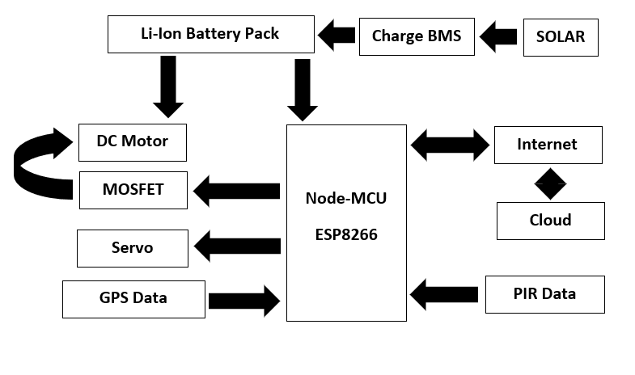

Fig 1: Block Diagram

1. **Flow Chart**

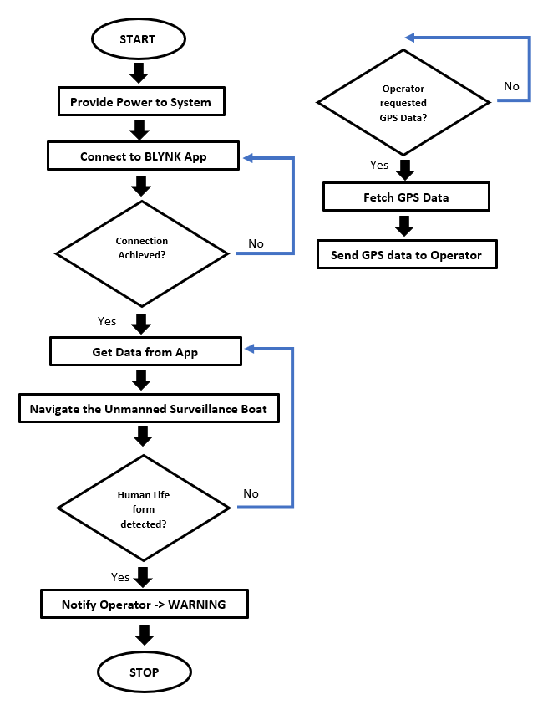

Fig 2- Flow Chart

1. **Hardware Description**

The hardware components of this Unmanned Surface Vehicle (USV) platform that can be used for multiple purpose consists of – NodeMCU as the main control system, a DC Motor as the main Actuator, Servo as the navigation Rudder control, MOSFET to provide PWM signal to DC Motor to control speed, PIR or Passive Infrared Sensor as Human Lifeform detector, 18650 Li-Ion Cells as power supply.

**Note** – For testing and simulation we have used Arduino which will later be replaced by – NodeMCU.

* 1. **Arduino Board**

Arduino is a hardware source platform. Like other programmable circuit boards, Arduino does not have a separate piece of hardware. The Software of Arduino uses a simplified version of C++, it provides an easier environment for doing projects. Atmega328 is the microcontroller used in Arduino. It is low power and high-performance microcontroller used to read and control the data from sensors. It has 14digital input/output pins, 6 analog inputs, and a reset button. The Arduino can be powered through a USB connection of 5V.

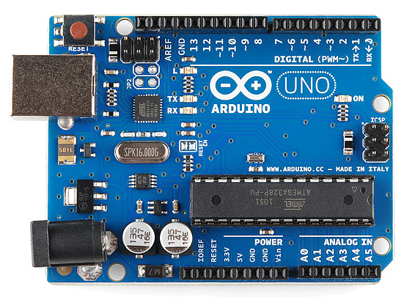

Fig 3- Arduino Uno Microcontroller

* 1. **NodeMCU ESP8266 12E**

The NodeMCU-ESP8266 is a microcontroller with Wi-Fi capability. It is an open source IoT platform. This small board allows microcontrollers to connect to a Wi-Fi network and make simple TCP/IP connections using Hayes-style commands. NodeMCU refers default to the firmware. Lua is a scripting language used by this firmware. The operating system and processor used in it is XTOS and ESP8266. It has a memory of 128KB and storage of 4MB. The power for the controller is provided through USB.

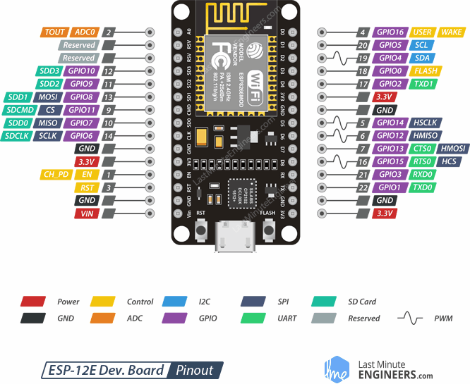

Fig 4 - NodeMCU Microcontroller Pinout

* 1. **Passive Infrared Sensor PIR**

PIR sensors allow you to sense motion, almost always used to detect whether a human has moved in or out of the sensors range. They are small, inexpensive, low-power, easy to use and don't wear out. For that reason, they are commonly found in appliances and gadgets used in homes or businesses. They are often referred to as PIR, "Passive Infrared", "Pyroelectric", or "IR motion" sensors.

[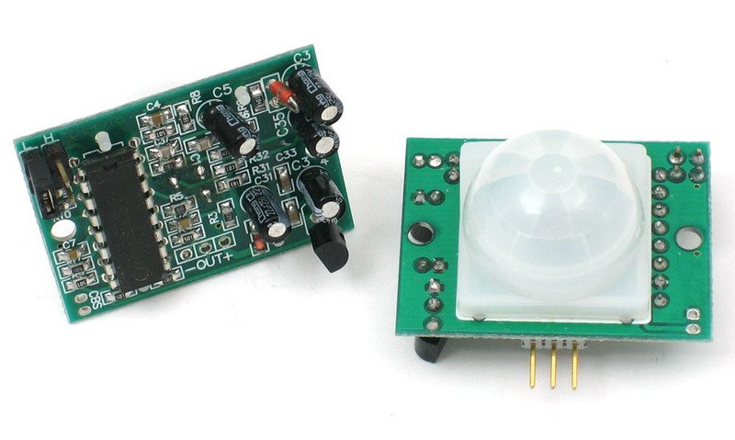](https://learn.adafruit.com/assets/503)

|  |
| --- |
| **Fig 5 – Passive Infrared Sensor** |

PIRs are basically made of a pyroelectric sensor (which you can see below as the round metal can with a rectangular crystal in the center), which can detect levels of infrared radiation. Everything emits some low-level radiation, and the hotter something is, the more radiation is emitted. The sensor in a motion detector is actually split in two halves. The reason for that is that we are looking to detect motion (change) not average IR levels. The two halves are wired up so that they cancel each other out. If one half sees more or less IR radiation than the other, the output will swing high or low.

* 1. **Li-ion 18650 Cell**

**18650 Cell Features and Technical Specifications**

* Nominal Voltage: 3.6V
* Nominal Capacity: 2,850 mAh
* Minimum Discharge Voltage: 3V
* Maximum Discharge current: 1C
* Charging Voltage: 4.2V (maximum)
* Charging current: 0.5C
* Charging Time: 3 hours (approx.)
* Charging Method: CC and CV
* Cell Weight: 48g (approx.)
* Cell Dimension: 18.4mm (dia) and 65mm (height)

**How to charge an 18650 Cell**

The charging voltage of 18650 cell is 4.2V and recommended charging current is 1A (0.5C). Again, a module like TP4056 will come in very handy to charge this module and will also provide protection while discharging.

Normally to achieve higher level of voltages more than one 18650 cells will be connected in series or parallel in that case care should be taken that all the cells are maintained in the same voltage levels, this process is called as cell balancing and is usually done using a BMS (Battery management system) which takes the responsibility of charging and discharging the batteries uniformly.

* 1. **Battery Management Circuit**

3S 11.1V 10A 18650 Lithium Battery Overcharge and Over-current Protection board (BMS) ensures the security of battery pack. This battery management system design and Suitable for: 10.8V (Rated voltage of polymer battery) 11.1V (18650 or 3.7V lithium battery rated voltage) 12.6V (Lithium battery full charge voltage)

**Features:**

* Three series of lithium battery protection board.
* Automatically cancel protection after protection conditions restore.
* With the function of overcharge protection, over discharge protection, short circuit protection, over-current protection.
* Suitable for lithium battery pack of 11.1V, 12V, 12.6V.
* Quiescent current < 30uA, so power consumption is small.

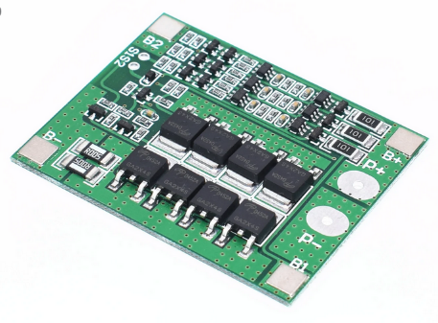

|  |
| --- |
| **Fig 6 – Battery Management Circuit** |

* 1. **MOSFET – Metal Oxide Semiconductor Field Effect Transistor.**

A MOSFET (Metal Oxide-Semiconductor Field Effect Transistor) is a semiconductor device that can be used as a solid-state switch. These are useful for controlling loads that draw more current, or require higher voltage, than a GPIO pin can supply. In their off state, MOSFETs are non-conducting, while in there on state, they have an extremely low resistance - often measured in milliohms. MOSFETs can only be used to switch DC loads.

MOSFETs have three pins, Source, Drain, and Gate. The source is connected to ground (or the positive voltage, in a p-channel MOSFET), the drain is connected to the load, and the gate is connected to a GPIO pin on the Espruino. The *voltage* on the gate determines whether current can flow from the drain to the load - no current flows to or from the gate (unlike a bipolar junction transistor) - this means that if the gate is allowed to float, the FET may turn on, or off, in response to ambient electrical fields, or very tiny currents. As demonstration, one can wire up a MOSFET normally, except connecting nothing to the gate pin, and then touch the gate while holding either ground or a positive voltage - even through your body’s resistance, you can turn the FET on and off! To ensure that a MOSFET remains off even if the pin is not connected (ex, after Espruino is reset), a pull-down resistor can be placed between gate and source.

MOSFETs only switch current flowing in one direction; they have a diode between source and drain in the other direction (in other words, if the drain (on an N-channel device) falls below the voltage on the source, current will flow from the source to the drain). This diode, the "body diode" is a consequence of the manufacturing process. This is not to be confused with the diode sometimes placed between the drain and the power supply for the load - this is separate, and should be included when driving an inductive load.

**N-channel vs P-channel –**

In an N-channel MOSFET, the source is connected to ground, the drain to the load, and the FET will turn on when a positive voltage is applied to the gate. N-channel MOSFETs are easier to work with, and are the most commonly used type. They are also easier to manufacture, and thus are available for lower prices with higher performance than p-channel MOSFETs.

In a P-channel MOSFET, the source is connected to a positive voltage, and the FET will turn on when the voltage on the gate is below the source voltage by a certain amount (Vgs < 0). This means that if you want to use a P-channel mosfet to switch voltages higher than 5V, you'll need another transistor (of some sort) to turn it on and off.

**MOSFETs vs Relays**

* MOSFETs consume essentially no power, while relays use a significant amount of power when turned on.
* MOSFETs can be driven with PWM. Relays can't.
* MOSFETs require a shared ground (or supply for p-channel), while relays completely isolate the circuit being driven.
* MOSFETs can only switch DC loads, while relays, being isolated, can switch AC as well.

**MOSFETs vs Bipolar Junction Transistors**

* MOSFETs are controlled by voltage, not current. There is negligible gate current, whereas a BJT has a non-negligible base current.
* MOSFETs often have a lower voltage drop in their on state.
* MOSFETs will turn themselves on if the gate is allowed to float, BJTs require current to flow, so they will not.
* MOSFETs are often more expensive, and were historically more vulnerable to static damage.

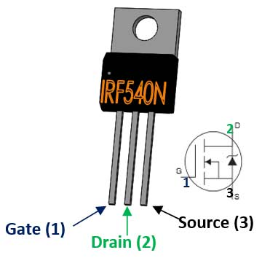

|  |
| --- |
| **Fig 7 - MOSFET** |

* 1. **DC Motor**

A DC motor may be an automatically commutated motor steam-powered from DC (DC). In DC motor, operation is predicated on easy electromagnetism. A current-carrying conductor generates a field; once this can be then placed in associate degree external magnetic field, it'll expertise a force proportional to the present within the conductor, and to the strength of the external field. Opposite (North and South) polarities of magnet attract, whereas like polarities (North and North, South and South) repel. the inner configuration of a DC motor is intended to harness the magnetic interaction between a current-carrying conductor associate degreed an external field to come up with motility motion.

1. **Servo Motor in Depth**

Servo is a general term for a closed loop control system.

A closed loop system uses the feedback signal to adjust the speed and direction of the motor to achieve the desired result.

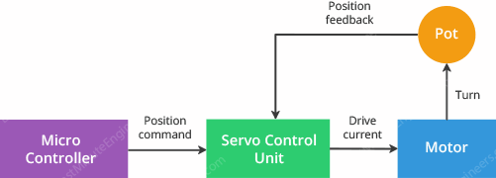

|  |
| --- |
| **Fig 8 –Block diagram of servo motor** |

RC servo motor works on the same principal. It contains a small DC motor connected to the output shaft through the gears.

The output shaft drives a servo arm and is also connected to a potentiometer (pot).

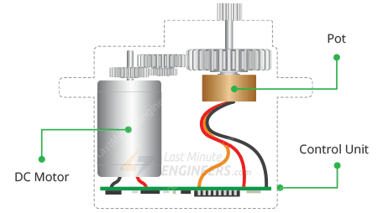

|  |
| --- |
| **Fig 9 – RC servo motor** |

The potentiometer provides position feedback to the servo control unit where the current position of the motor is compared to the target position.

According to the error, the control unit corrects the actual position of the motor so that it matches the target position.

* 1. **How Servo Motors Work?**

You can control the servo motor by sending a series of pulses to the signal line. A conventional analog servo motor expects to receive a pulse roughly every 20 milliseconds (i.e., signal should be 50Hz).

The length of the pulse determines the position of the servo motor.

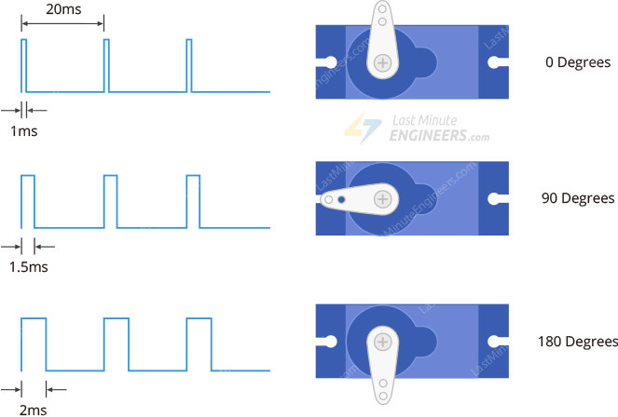

|  |
| --- |
| **Fig 10 – Working principle of Servo Motor** |

* If the pulse is high for 1ms, then the servo angle will be zero.
* If the pulse is high for 1.5ms, then the servo will be at its center position.
* If the pulse is high for 2ms, then the servo will at 180 degrees.
* Pulses ranging between 1ms and 2ms will move the servo shaft through the full 180 degrees of its travel.

## **Servo Motor Pinout**

Servo motors typically have three connections and are as follows:

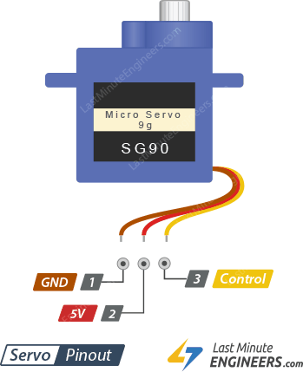

|  |
| --- |
| **Fig 11 – Servo motor Pinout** |

**GND** is a common ground for both the motor and logic.

**5V** is a positive voltage that powers the servo.

**Control** is input for the control system.

* 1. **Wiring Servo Motor to Arduino UNO**

hook up the servo motor up to the Arduino.

For example, let’s use SG90 Micro Servo Motor. It runs on 4.8-6VDC (5V Typical) and can rotate approximately 180 degrees (90 in each direction).

It consumes around 10mA at idle and 100mA to 250mA when moving, so we can power it up through 5-volt output on the Arduino.

If you have a servo that consumes more than 250mA, consider using a separate power supply for your servo.

Connect the Red wire to the 5V on Arduino (or DC jack) and Black/Brown wire to ground. Finally connect the Orange/Yellow wire to the PWM enabled pin 9.

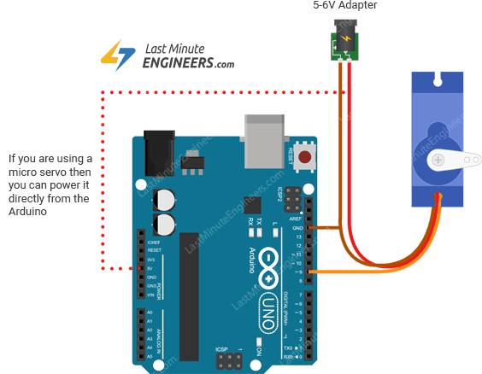

|  |
| --- |
| **Fig 12 – Wiring Servo Motor to Arduino Uno** |

* 1. **Arduino Code – Sweep**

For our first Arduino sketch, we will use one of the built-in examples that come with the Arduino IDE.

Go to the Examples sub-menu. Select the Servo and Load the Sweep sketch.

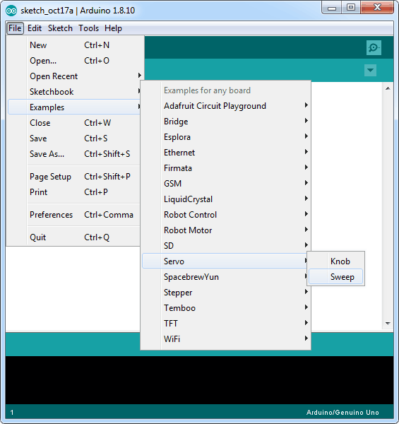

After uploading the sketch. It is observed that the motor starts moving in one direction and then going back in another immediately.

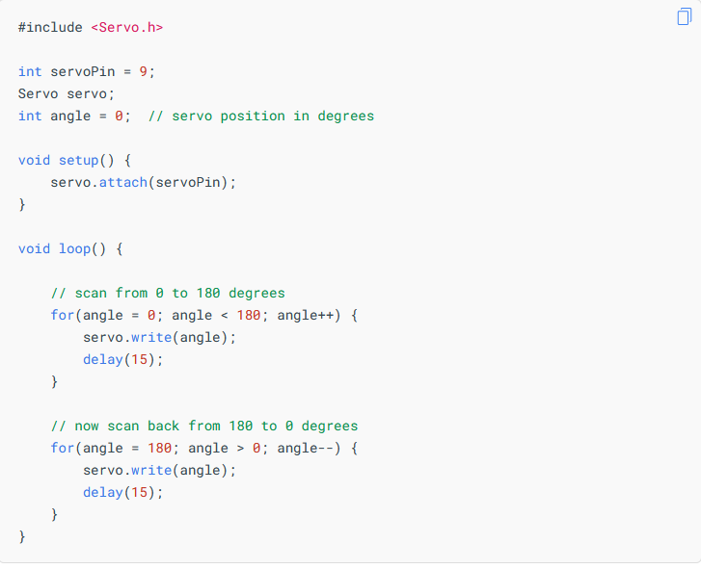

### **Explanation:**

Controlling servos is not an easy task, but luckily for us, Arduino IDE already contains a very nice library called **Servo**. It includes simple commands so that you can quickly instruct the servo to turn to a particular angle.

If you are going to use these commands, you need to tell the Arduino IDE that you are using the library with this command:

#include <Servo.h>

The next thing we do is declare the Arduino pin to which the control pin of the servo motor is connected.

int servoPin = 9;

Below line creates a servo object.

Servo servo;

You can actually define up to eight servos in this way, for example, if we had two servos, then we could write something like this:

Servo servo1;

Servo servo2;

The variable angle is used to store the current angle of the servo in degrees.

int angle = 0;

In the setup function, we link the servo object to the pin that will control the servo using this command:

servo.attach(servoPin);

The loop function actually contains two for loops. The first loop increases the angle in one direction and the second in the opposite direction.

Below command tells the servo to update its position to the specified angle.

servo.write(angle);

1. **Power Supply**

The ac voltage, typically 220V rms, is connected to a transformer, which steps that ac voltage down to the level of the desired dc output. A diode rectifier then provides a full-wave rectified voltage that is initially filtered by a simple capacitor filter to produce a dc voltage. This resulting dc voltage usually has some ripple or ac voltage variation. A regulator circuit removes the ripples and also remains the same dc value even if the input dc voltage varies, or the load connected to the output dc voltage changes. This voltage regulation is usually obtained using one of the popular voltage regulator IC units.

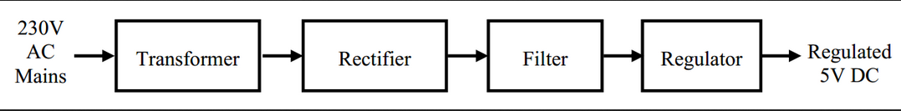

Fig 13- Bridge Rectifier Block Diagram

**8.2 Working Principle**

**Transformer** The potential electrical device can step down the facility offer voltage (0-230V) to (0-6V) level. Then the secondary of the potential electrical device are connected to the exactness rectifier, that is built with the assistance of op–amp. the benefits of victimization exactness rectifier area unit it'll provide peak voltage output as DC, remainder of the circuits can provide solely RMS output.

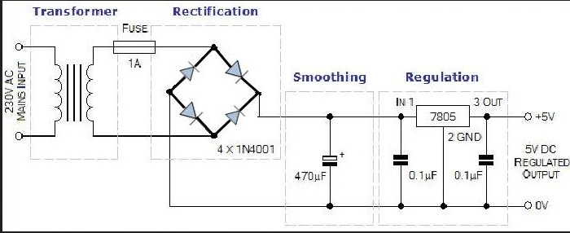

Fig 14- Bridge Rectifier Circuit Diagram

1. **Software Requirement - Blynk**

Blynk was designed for the Internet of Things. It can control hardware remotely, it can display sensor data, it can store data, visualize it and do many other cool things.

There are three major components in the platform:

* **Blynk App** - allows to you create amazing interfaces for your projects using various widgets we provide.
* **Blynk Server** - responsible for all the communications between the smartphone and hardware. You can use our Blynk Cloud or run your private Blynk server locally. It’s open-source, could easily handle thousands of devices and can even be launched on a Raspberry Pi.
* **Blynk Libraries** - for all the popular hardware platforms - enable communication with the server and process all the incoming and outcoming commands.

Now imagine: every time you press a Button in the Blynk app, the message travels to the Blynk Cloud, where it magically finds its way to your hardware. It works the same in the opposite direction and everything happens in a blynk of an eye.

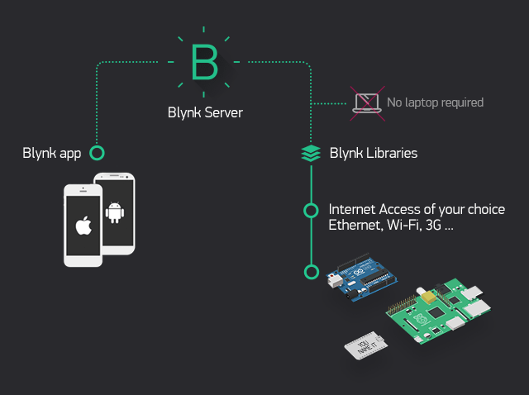

|  |
| --- |
| **Fig 15 – Blynk App** |

**Features**

* Similar API & UI for all supported hardware & devices
* Connection to the cloud using:
  + Wi-Fi
  + Bluetooth and BLE
  + Ethernet
  + USB (Serial)
  + GSM
  + …
* Set of easy-to-use Widgets
* Direct pin manipulation with no code writing
* Easy to integrate and add new functionality using virtual pins
* History data monitoring via Super Chart widget
* Device-to-Device communication using Bridge Widget
* Sending emails, tweets, push notifications, etc.
* … new features are constantly added!

You can find example sketches covering basic Blynk Features. They are included in the library. All the sketches are designed to be easily combined with each other.

* 1. **Blynk Requirements –**

**1. Hardware.**

An Arduino, Raspberry Pi, or a similar development kit.

**Blynk works over the Internet.** This means that the hardware you choose should be able to connect to the internet. Some of the boards, like Arduino Uno will need an Ethernet or Wi-Fi Shield to communicate, others are already Internet-enabled: like the ESP8266, Raspberry Pi with Wi-Fi dongle, Particle Photon or SparkFun Blynk Board. But even if you don’t have a shield, you can connect it over USB to your laptop or desktop

**2. A Smartphone.**

1. **Internet of Things (IoT)**

The Internet of Things (IoT) refers to the ever-growing network of physical objects that feature an IP address for internet connectivity, and the communication that occurs between these objects and other Internet-enabled devices and systems.

In simple words, Internet of Things (IoT) is an ecosystem of connected physical objects that are accessible through the internet.

It is also referred to as Machine-to-Machine (M2M), Skynet or Internet of Everything.

The Internet of things refers to a type of network to connect anything with the Internet based on stipulated protocols through information sensing equipment’s to conduct information exchange and communications in order to achieve smart recognitions, positioning, tracing, monitoring, and administration. In this paper we briefly discussed about what IOT is, how IOT enables different technologies, about its architecture, characteristics & applications, IOT functional view & what are the future challenges for IOT.

The IOT concept was coined by a member of the Radio Frequency Identification (RFID) development community in 1999, and it has recently become more relevant to the practical world largely because of the growth of mobile devices, embedded and ubiquitous communication, cloud computing and data analytics.

* 1. **Introduction to IoT**

Imagine a world where billions of objects can sense, communicate and share information, all interconnected over public or private Internet Protocol (IP) networks. These interconnected objects have data regularly collected, analyzed and used to initiate action, providing a wealth of intelligence for planning, management and decision making. This is the world of the Internet of Things (IOT). Internet of things common definition is defining as: Internet of things (IOT) is a network of physical objects. The internet is not only a network of computers, but it has evolved into a network of device of all type and sizes , vehicles, smart phones, home appliances, toys, cameras, medical instruments and industrial systems, animals, people, buildings, all connected ,all communicating & sharing information based on stipulated protocols in order to achieve smart reorganizations, positioning, tracing, safe & control & even personal real time online monitoring , online upgrade, process control & administration. We define IOT into three categories as below:

Internet of things is an internet of three things:

(1). People to people,

(2) People to machine /things,

(3) Things /machine to things /machine, Interacting through internet.

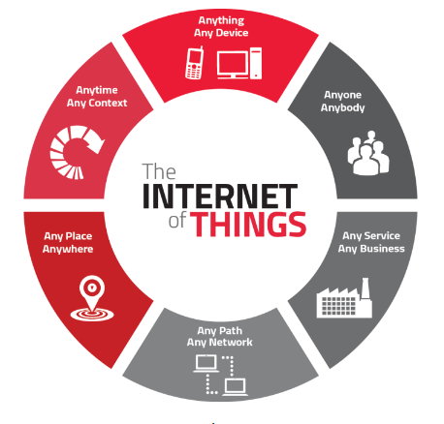

Fig 16- Internet of Things

* 1. **Enabling Technologies for IoT**

Internet of things (IoT) is a global infrastructure for the information society, enabling advanced services by interconnecting (physical and virtual) things based on existing and evolving interoperable information and communication technologies. With the Internet of Things, the communication is extended via Internet to all the things that surround us. The Internet of Things is much more than machine to machine communication, wireless sensor networks, sensor networks, 2G/3G/4G, GSM, GPRS, RFID, WI-FI, GPS, microcontroller, microprocessor etc. These are considered as being the enabling technologies that make “Internet of Things” applications possible.

* 1. **Characteristics**

The fundamental characteristics of the IoT are as follows:

**Interconnectivity:** With regard to the IoT, anything can be interconnected with the global information and communication infrastructure.

**Things-related services:** The IoT is capable of providing thing-related services within the constraints of things, such as privacy protection and semantic consistency between physical things and their associated virtual things. In order to provide thing-related services within the constraints of things, both the technologies in physical world and information world will change.

**Heterogeneity:** The devices in the IoT are heterogeneous as based on different hardware platforms and networks. They can interact with other devices or service platforms through different networks.

**Dynamic changes:** The state of devices change dynamically, e.g., sleeping and waking up, connected and/or disconnected as well as the context of devices including location and speed. Moreover, the number of devices can change dynamically.

**Enormous scale:** The number of devices that need to be managed and that communicate with each other will be at least an order of magnitude larger than the devices connected to the current Internet. Even more critical will be the management of the data generated and their interpretation for application purposes. This relates to semantics of data, as well as efficient data handling.

**Safety:** As we gain benefits from the IoT, we must not forget about safety. As both the creators and recipients of the IoT, we must design for safety. This includes the safety of our personal data and the safety of our physical well-being. Securing the endpoints, the networks, and the data moving across all of it means creating a security paradigm that will scale.

**Connectivity:** Connectivity enables network accessibility and compatibility. Accessibility is getting on a network while compatibility provides the common ability to consume and produce data.

* 1. **Advantages of Internet of Things**

**Access information**

You can easily access data and information that is sitting far from your location, in real time. This is possible because of the network of devices; a person can access any information sitting from any part of the globe. This makes it very convenient for people to go about their work, even if they are not physically present.

**Communication**

Better communication is possible over a network of interconnected devices, making the communication of devices more transparent, which reduces inefficiencies. Processes, where machine have to communicate with each other, are made more efficient and produce better, faster results. The perfect example for this is machinery at a manufacturing or production unit.

**Cost-effective**

As mentioned in the point above, communication between electronic devices is made easier because of IoT. This helps people in daily tasks. Transferring data packets over a connected network save time and money. The same data that would take a long time to transfer can now be done much faster, thanks to IoT.

**Automation**

Automation is the need of the hour to manage everyday tasks without human intervention. Automating tasks in a business helps boost the quality of services and reduce the level of human intervention.

* 1. **Disadvantages of Internet of Things**

**Privacy & security**

In today’s tech-driven world, each and every device that an individual uses is connected via the internet. This increases the risk of any leakage of data that might be important. This is a major drawback of sharing information, as confidential information might not be safe & could be hacked by third parties easily.

**Complexity**

A diverse network that connects various devices is what we call IoT. A single loophole can affect the entire system. This is by far the most complicated aspect of the internet of things that can have a tremendous effect.

**Lesser jobs**

With every task being automated, the need for human labor will reduce drastically. This will have a direct impact on employability. As we head into the future of IoT, there will be a visible decline in the hiring process of professionals.

**Dependability**

We may not notice it, but we are witnessing a major shift in technology and its implementation in everyday lives. There is no doubt that technology is dominating our lifestyle, reflecting a human’s dependability on technology. In case of a bug in the system, there are high chances of every related device getting corrupted.

1. **Circuit and Simulation**

We will construct the circuit step by step on an online simulation platform – TinkerCAD.

In the world of 3D modeling, TinkerCAD has established itself as a worthy introduction to computer-aided design (CAD). It’s a free and intuitive web-based CAD program that anyone can use. In fact, if you want to get started with TinkerCAD, we even have a beginner’s tutorial to get you going.

Recently, TinkerCAD has introduced something new: An expansion to include circuits in its design capability called TinkerCAD Circuits. This brings a whole new side to TinkerCAD, revolving around simulating circuits with Arduino.

Arduino is an open-source electronic prototyping platform that also sells microcontrollers. TinkerCAD Circuits allows anyone to virtually create and program Arduino projects without the need for physical hardware.

* 1. **Interfacing DC Motor**

A DC motor is a high-power device that runs on voltages much higher than that of an Arduino. A DC Motor mostly runs on voltages – 12v, 24v, 36v etc. whereas Arduino being a 5v device and ESP8266 a 3.3v device. A DC motor also require a much higher current for steady operation, approximately 8 Amps when stalled. Thus, we cannot connect a DC motor directly to the outputs of an Arduino. To solve this problem MOSFET comes into Play. A MOSFET is used as an electronic switch to turn on/off the motor.

MOSFETs have three pins, Source, Drain, and Gate. The source is connected to ground (or the positive voltage, in a p-channel MOSFET), the drain is connected to the load, and the gate is connected to a GPIO pin on the Arduino.

The *voltage* on the gate determines whether current can flow from the drain to the load - no current flows to or from the gate (unlike a bipolar junction transistor) - this means that if the gate is allowed to float, the FET may turn on, or off, in response to ambient electrical fields, or very tiny currents. As demonstration, one can wire up a MOSFET normally, except connecting nothing to the gate pin, and then touch the gate while holding either ground or a positive voltage - even through your body’s resistance, you can turn the FET on and off! To ensure that a MOSFET remains off even if the pin is not connected (ex, after Arduino is reset), a pull-down resistor can be placed between gate and source.

* + 1. **Circuit Diagram –**

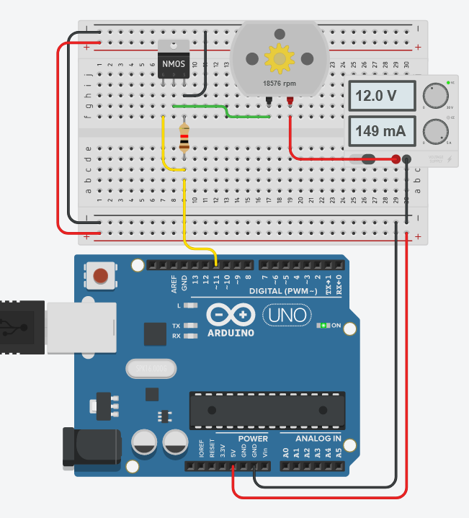

* + 1. **Code Segment**

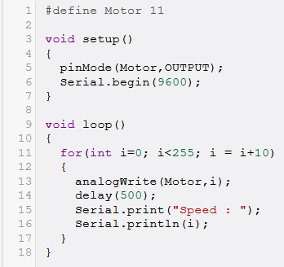

* + 1. 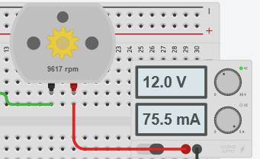**Output**

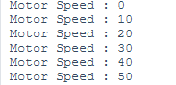

* 1. **Interfacing Servo Motor**

Interfacing Servo Motor with Arduino has been discussed in detail previously. Similarly, here we have connected the Servo Motor to the Arduino following the wiring Diagram Shown Below –

**Servo Pins** **Arduino**

VCC 5V or Vin ext.

Signal Digital Pin 9

GND GND

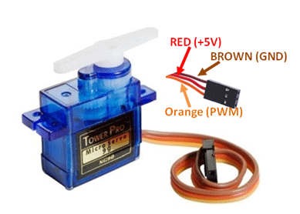

|  |
| --- |
| **Fig 17 – Interfacing Servo Motor** |

* + 1. **Circuit Diagram**

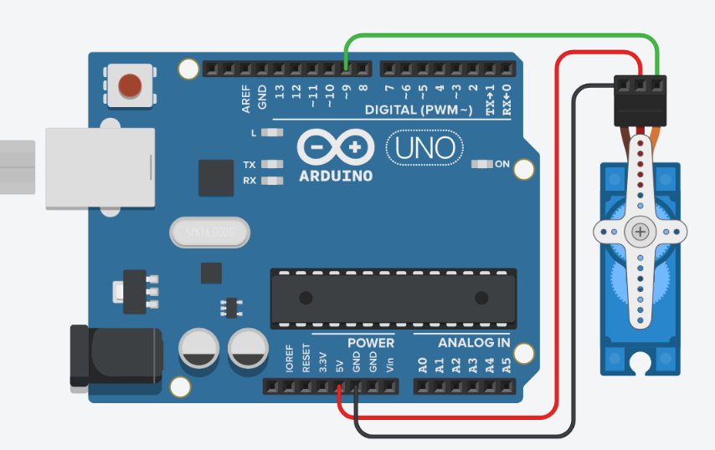

* + 1. **Code Segment**

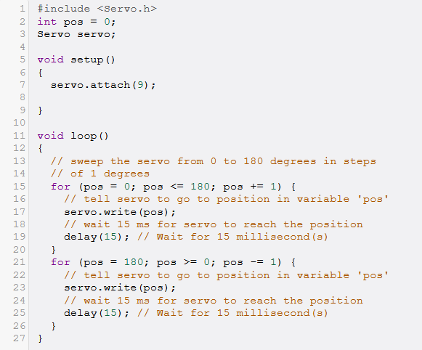In this code we have included the Servo.h Library to work with Servo.

Then a Servo object is created by name servo. This object is attached to digital Pin 9 of Arduino, we use the attach() function for this purpose.

We then use a for loop to rotate the servo in small steps.

The write() function is used to write degrees to the servo object.

* + 1. **Observation –**

When we simulate this circuit, we observe that the servo starts rotating from 0-180 degree and then starts rotating backwards from 180-0. This entire operation keeps repeating indefinitely forever.

* 1. **Combining DC motor and Servo Interface Circuits** 
     1. **Circuit Diagram –**

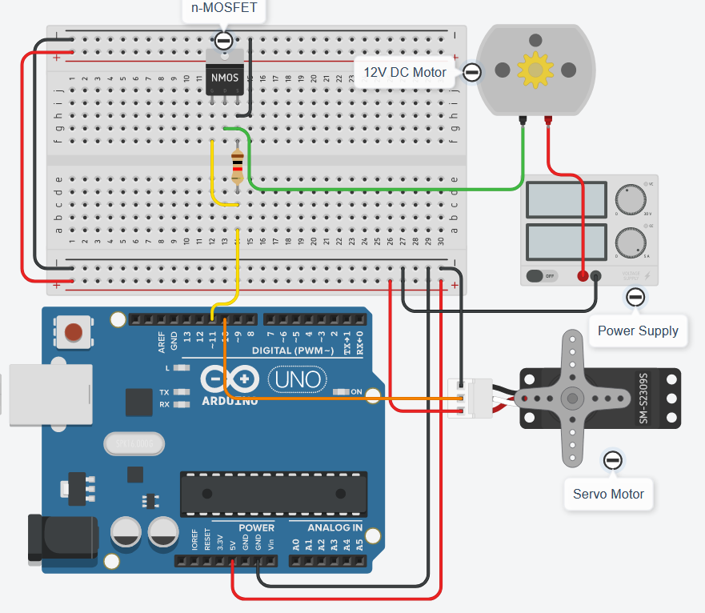

1. **Code Segment**

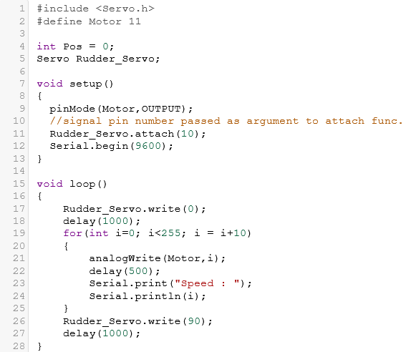

1. **List of Materials**

**Parts Qty**

Node MCU 1.0V Qty: 1

9g Micro Servo Qty: 2

PIR (motion) sensor Qty: 1

Diode Rectifier - 1A 50V

$0.11 x Qty: 1

Hobby Motor - Gear

$1.95 x Qty: 1

Standard Size - High Torque - Metal Gear Servo - MG995

$19.95 x Qty: 1

Wall Adapter Power Supply - 12VDC 2A

$15.77 x Qty: 1

Ublox NEO-6M GPS Module

$7.96 x Qty: 1

Ultrasonic Sensor - HC-SR04

$3.95 x Qty: 2

470 Ohm Resistor

$0.1 x Qty: 2

1K Ohm Resistor

$0.1 x Qty: 2

N-Channel MOSFET 60V 30A

$1.46 x Qty: 1

10K Ohm Resistor

$0.1 x Qty: 1

Female DC Power adapter - 2.1mm jack to screw terminal block

$2.00 x Qty: 1

USB micro-B Cable - 6 Foot

$2.98 x Qty: 1

Voltage Regulator 5v

$0.5 x Qty: 1

Capacitor Ceramic 100nF

$0.64 x Qty: 1

Electrolytic Capacitor - 1uF/50V

$0.28 x Qty: 1

BreadBoard

$8.25 x Qty: 2

HeatSink TO-220

$0.41 x Qty: 1

Jumper Wires Pack - M/M

$1.95 x Qty: 3

Jumper Wires Pack - M/F

$1.95 x Qty: 1

1. **Advantages**

* The IOT based Unmanned Surface Vehicle (USV) can be used to do surveillance purpose, rescue purpose with very easily through a smartphone app with trivial amount of life risk.
* The solar panel used here also help us make this vehicle run on green energy to some extent. The cost of battery or need for long-lasting battery are redundant and it’s been made to be more eco-friendly.
* A night vision camera or video image processor can be mounted on top of this vehicle making it efficient for rescue purpose or surveillance during night time.
* It can be used for seaweed farming. Using USV helps in reducing the operation cost to a great extent.
* Being equipped with PIR sensors which will help us in warning about unauthorized movement if any. Thus, can be used for surveillance in places that are hard to keep an eye on like a maritime border.
* The system can send us weather data which can help us know about the weather in parts where it’s stationed. For example, if the boat is stationed at a far of location in sea and provide us with information about any kind of storm then fishermen can be warned before-hand. Many lives will be saved.
* As discussed earlier, this system being entirely IOT based, any function that we want to perform can be done without any human-machine interaction. Everything will be done through a smartphone, with a single tap. Thus, it’s risk free and the amount of work needed is very trivial.
* If used in defense purpose, the data protection and privacy issues can also be dealt with. The data stored in the cloud can be manipulated, made copy of, encrypted and backed up as per our need.
* Does not require additional structural and can be used efficiently.
* It is very easy to implement
* All parts are readily available.
* High Accuracy and responsiveness.
* Dependable and long life.

1. **Application**

* defense
* search and rescue.
* Scientific research

1. **Conclusion**

This paper represents the progress on the design and development of Multi-Purpose Unmanned Surface Vehicles for Surveillance and Rescue Operations system using the concept of Internet of things. The experimental setup has been calibrated and the performance of the system has verified. The developed system checks the security on the coast. These data will be finally stored in a cloud for future analysis in the final prototype. Along with the security the vehicle can also rescue any people. The main objective is we will be aware of the defense,search and rescue from the vehicles. Hence a solution for maritime accidents. As of now the circuit is developed and simulated on TinkerCAD online simulation website.

1. **Future Scope**

The system can be integrated with GPRS / GSM modules for notifying the higher authorities by Text Messages for Rapid Action.

The system can also get a Wi-Fi module for real time tracking of Offenders. And the co-ordinates can be sent via Text Message to the respective Authorities in charge.

1. **References**

Wikipedia

[Thedigitalship.com](https://thedigitalship.com/news/maritime-satellite-communications/item/4721-danes-back-maritime-iot-project)

[www.arduino.cc](http://www.arduino.cc › reference › board)

www.researchgate.net